Demonstrating Distribution Layer Functions

**Components:** Router, Switch, Device (PC)

**Theory:** The distribution layer is the smart layer in the three-layer model. Routing, filtering, and QoS policies are managed at the distribution layer. Distribution layer devices also often manage individual branch-office WAN connections. This layer is also called the Workgroup layer. **Cisco Packet Tracer Setup:-**

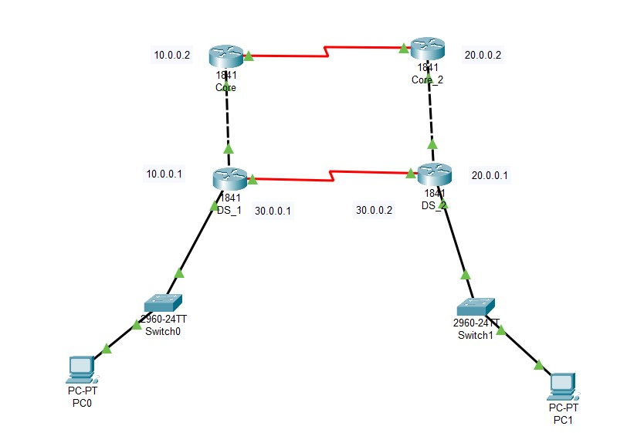

**Implementation:**

**Step 1:** Arranging devices and creating connections using Ethernet and serial cable between devices according to the image above

**Step 2:** Configuring all devices according to the table below

|  |  |  |  |
| --- | --- | --- | --- |
| Device | Interface | IPv4 address | Other |
| PC0 | IP config | 172.16.1.2 | Default Gateway: 172.16.1.1 |
| PC1 | IP config | 192.168.1.2 | Default Gateway: 192.168.1.1 |
| DS_1 | F0/0 | 172.16.1.1 |  |
|  | F0/1 | 10.0.0.1 |  |
|  | S0/0/0 | 30.0.0.1 | Clock rate: 64000 |
|  | RIP v2 | 10.0.0.0  30.0.0.0  172.16.0.0 |  |
| DS_2 | F0/0 | 192.168.1.1 |  |
|  | F0/1 | 20.0.0.1 |  |
|  | S0/0/0 | 30.0.0.2 | Clock rate: 64000 |
|  | RIP v2 | 20.0.0.0  30.0.0.0  192.168.1.0 |  |
| Core_1 | F0/0 | 10.0.0.2 |  |
|  | S0/0/0 | 40.0.0.1 |  |
|  | RIP v2 | 10.0.0.0  40.0.0.0 |  |
| Core_2 | F0/0 | 20.0.0.2 |  |
|  | S0/0/0 | 40.0.0.2 | Clock rate: 64000 |
|  | RIP v2 | 20.0.0.0  40.0.0.0 |  |

**Output:**

